Access/Download Instructor Reports

- Use the link provided in the email from idp@purdue.edu, or log in to:
https://purdue.evaluationkit.com.
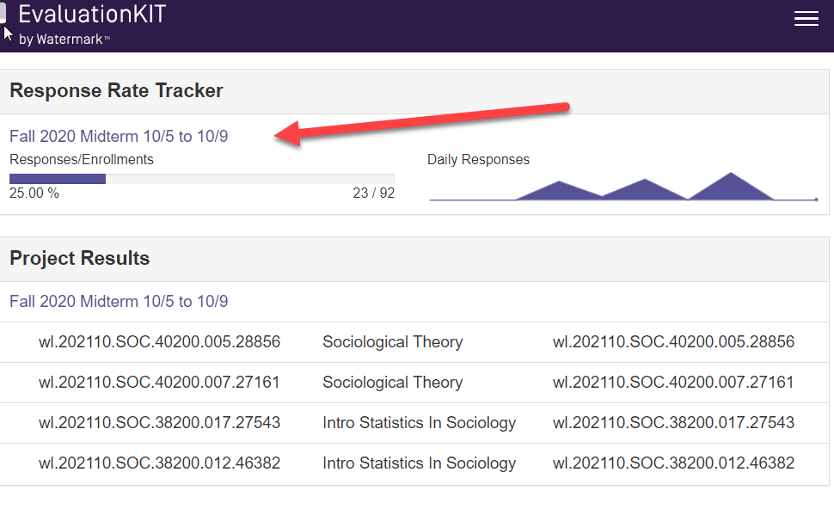
- The first portion shows the ‘Response Rate Tracker’. Here you can view final response rates for each course.

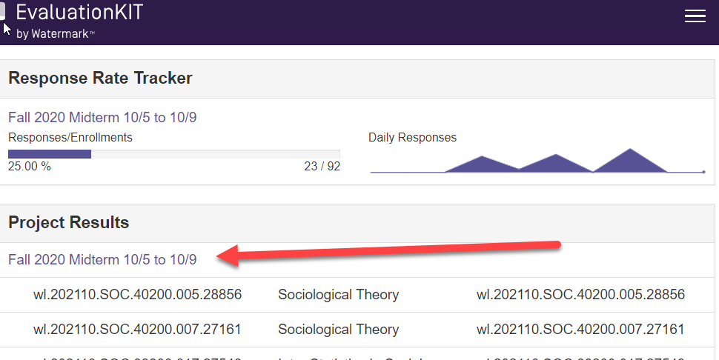
- Under ‘Project Results’, click on desired evaluation term.

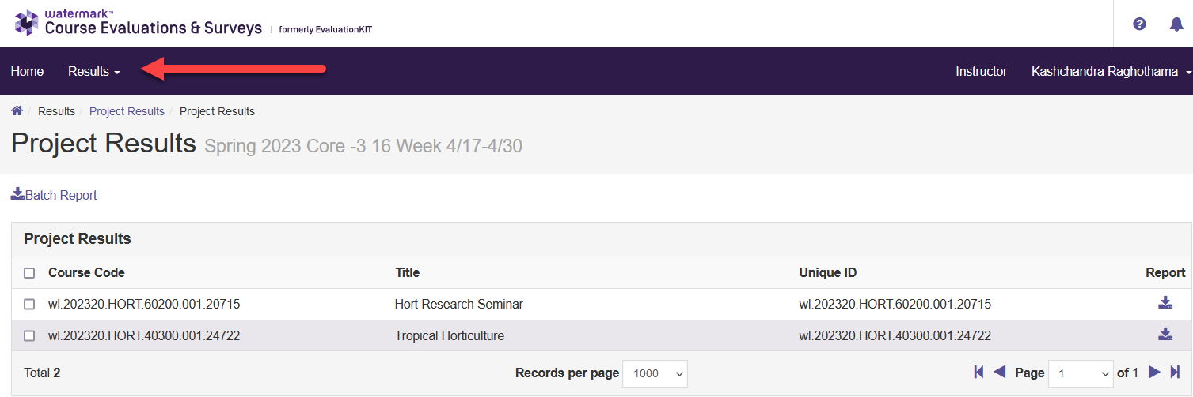
- To see all individual reports, click on the drop-down arrow for ‘Results’, then ‘Instructor Results’. (To run a Batch report, see page below.)

- Choose the project (term/semester), then ‘Select’.
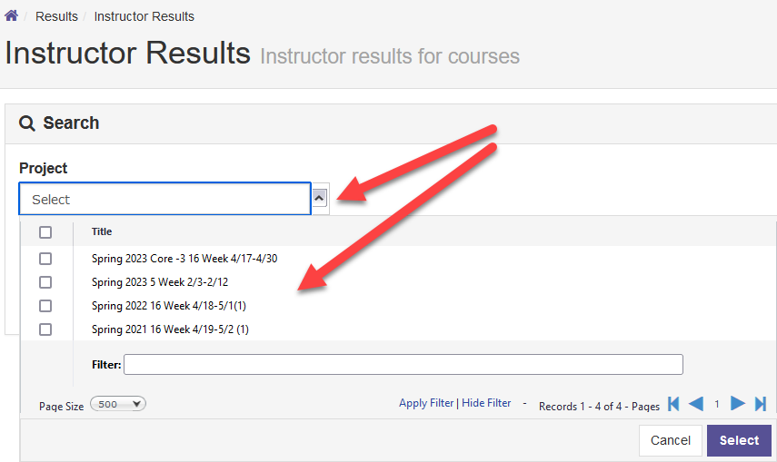

- Select the desired type of report on the drop-down menu. ‘Detailed Report + Comments’ is recommended (required for Midterm results).

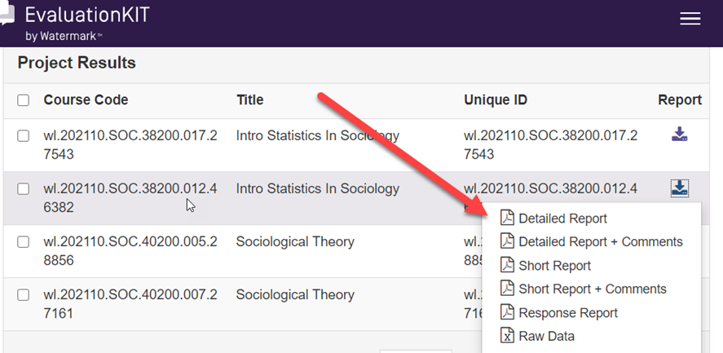

- You will then have the option to open or save the file.

- NOTE: For Midterm results, you must pick a report option that includes “+ Comments” or “Raw Data” in the title. Responses will not appear in the short reports.
- NOTE: Zero respondents will show “No Results Found” when creating a report

Create a Batch Report

- Follow the above steps #1-3.
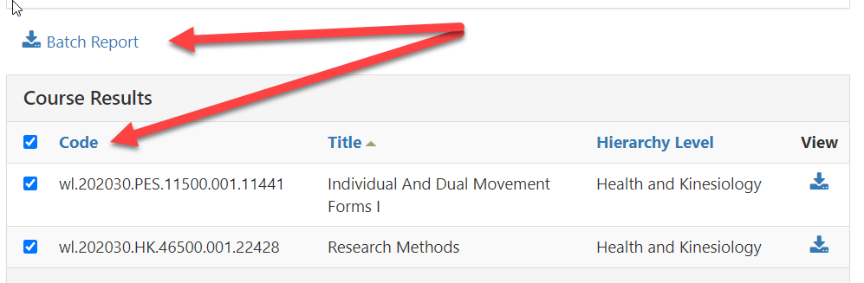
- Scroll down and select the desired courses. Then click on ‘Batch Report’.

- Select the type of report you want, add a ‘Report Name’, and click ‘Go’.
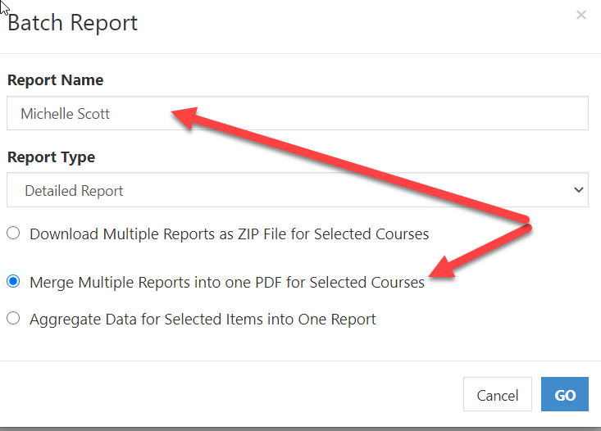
- A message will appear that your report is being generated and an email alert will be sent when the report is ready. Check your email for a message from Course Evaluations and Surveys with a link to the reports.

- NOTE: Zero respondents will show “No Results Found” when creating a report.

